1. Retrieve the names of passengers who survived the Titanic disaster.

SELECT Name

FROM product.train

WHERE survived = 1;

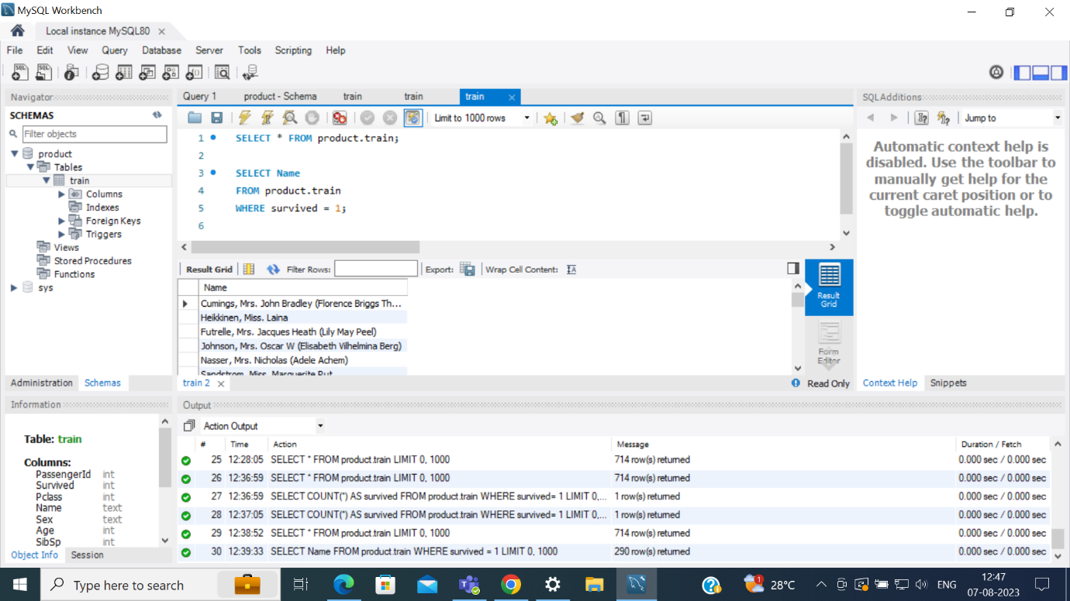

1. Find the names and ages of the five oldest survivors.

SELECT Name, Age FROM product.train WHERE survived = 1 ORDER BY Age DESC LIMIT 5;

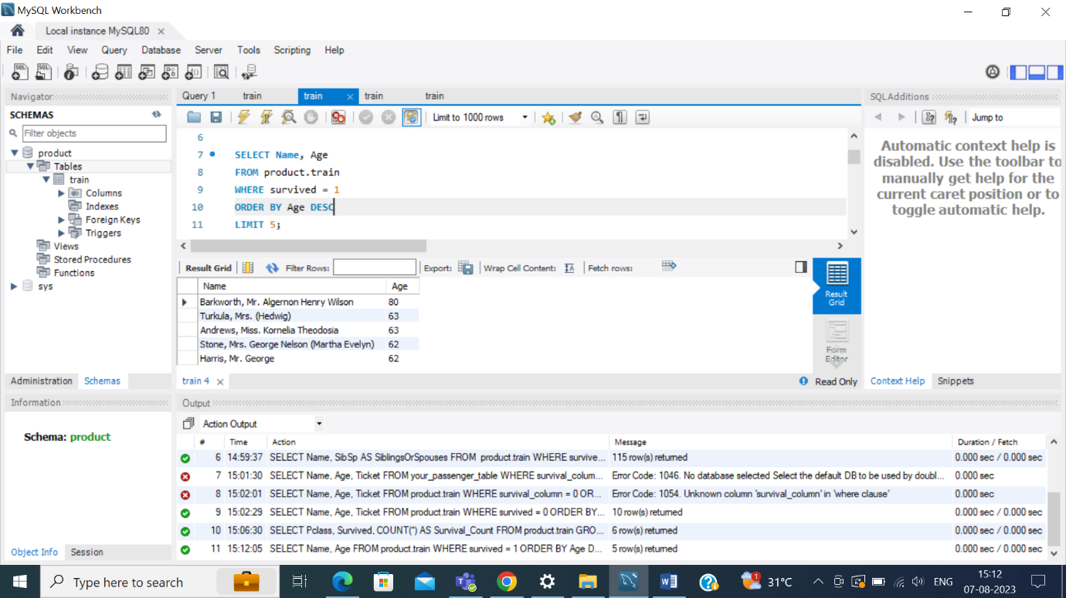

1. Calculate the average age of passengers who did not survive, and also the average age of passengers who survived, grouped by sex.

SELECT survived,Sex,

AVG(CASE WHEN survived=0 THEN Age END) AS Avgage_notsurvived,

AVG(CASE WHEN survived=1 THEN Age END) AS Avgage_survived

FROM product.train

GROUP BY Survived,Sex;

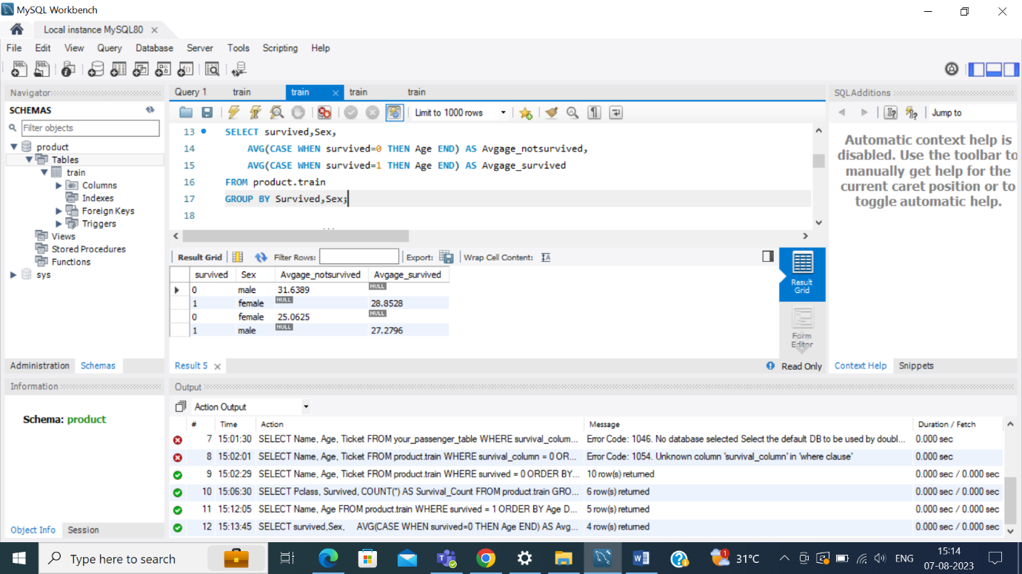

d) . Count the number of males and females

SELECT Sex, COUNT(*) AS count

FROM product.train

GROUP BY Sex;

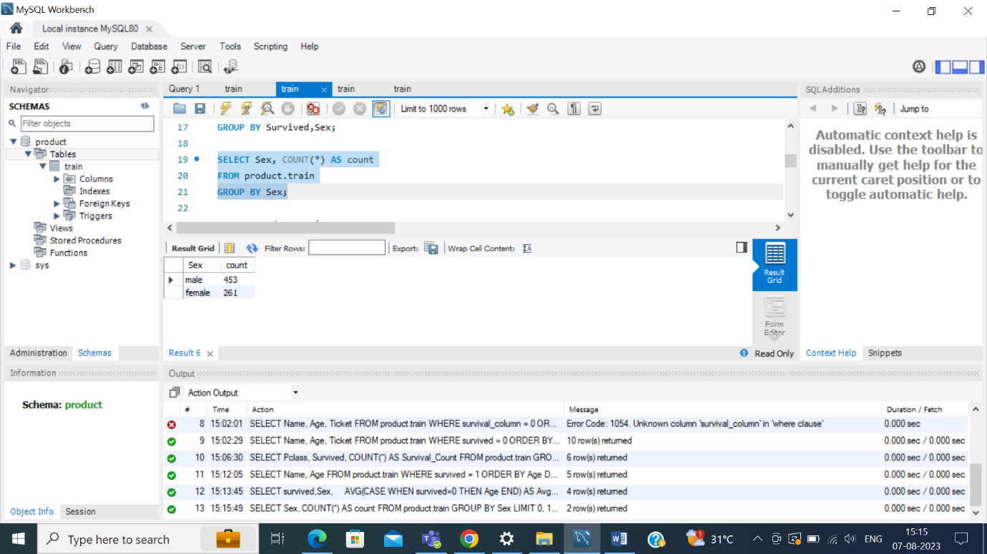

e) Update the cabin class of a Futrelle, Mrs. Jacques Heath (Lily May Peel) to 3rd class

UPDATE product.train

SET Pclass=3

WHERE Name = 'Futrelle, Mrs. Jacques Heath (Lily May Peel)';

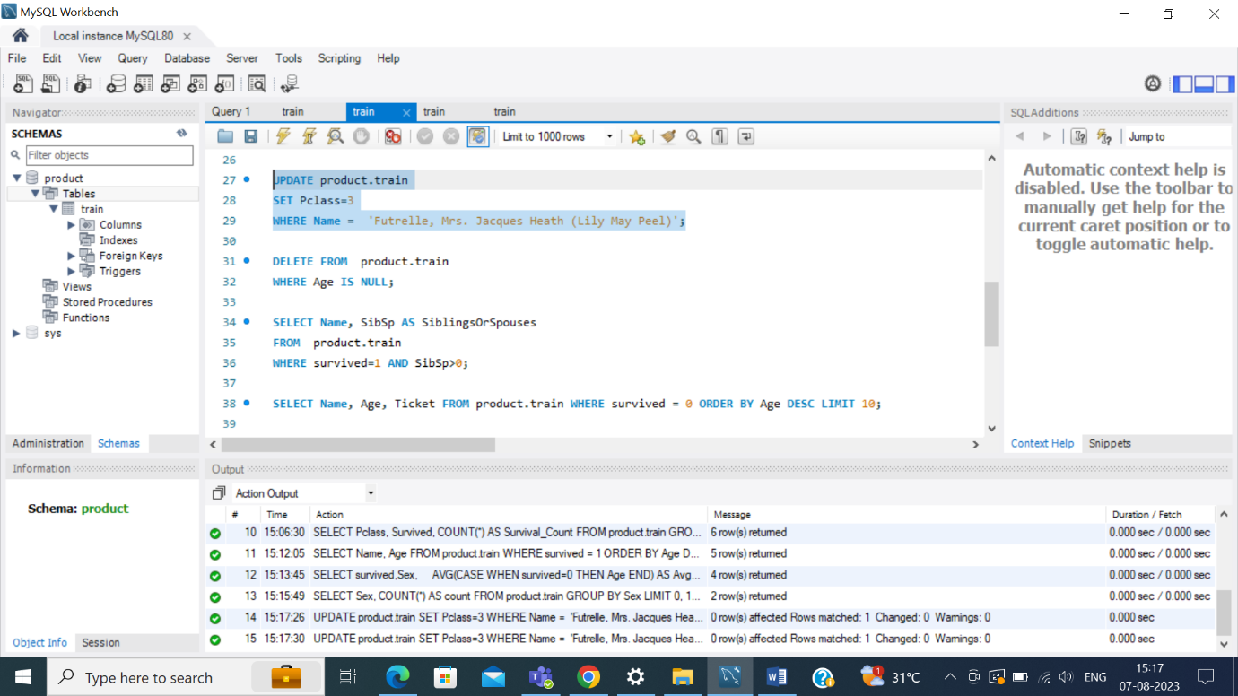

f) Delete all passengers who did not have a recorded age

DELETE FROM product.train

WHERE Age IS NULL;

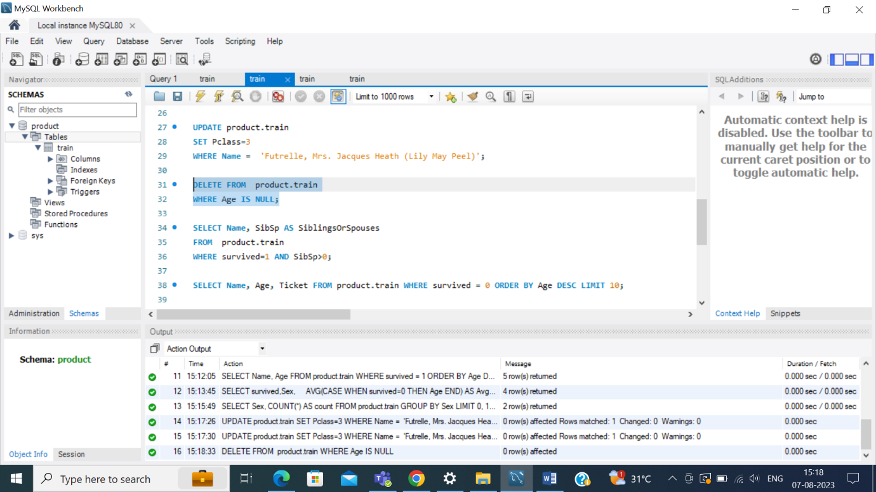

g) Retrieve the names of passengers who survived and have siblings or spouses on board, along with the count of their siblings or spouses

SELECT Name, SibSp AS SiblingsOrSpouses

FROM product.train

WHERE survived=1 AND SibSp>0;

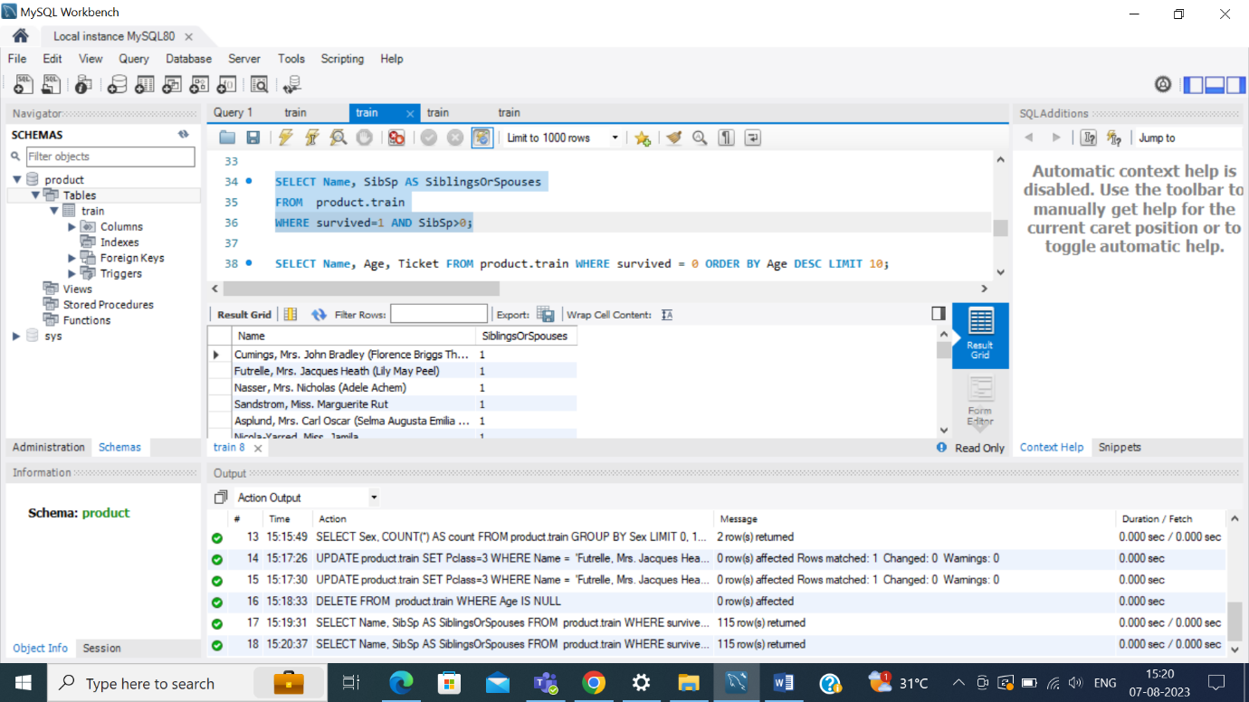

h) Find the top 10 oldest passengers who did not survive, along with their ages and ticket numbers

SELECT Name, Age, Ticket FROM product.train WHERE survived = 0 ORDER BY Age DESC LIMIT 10;

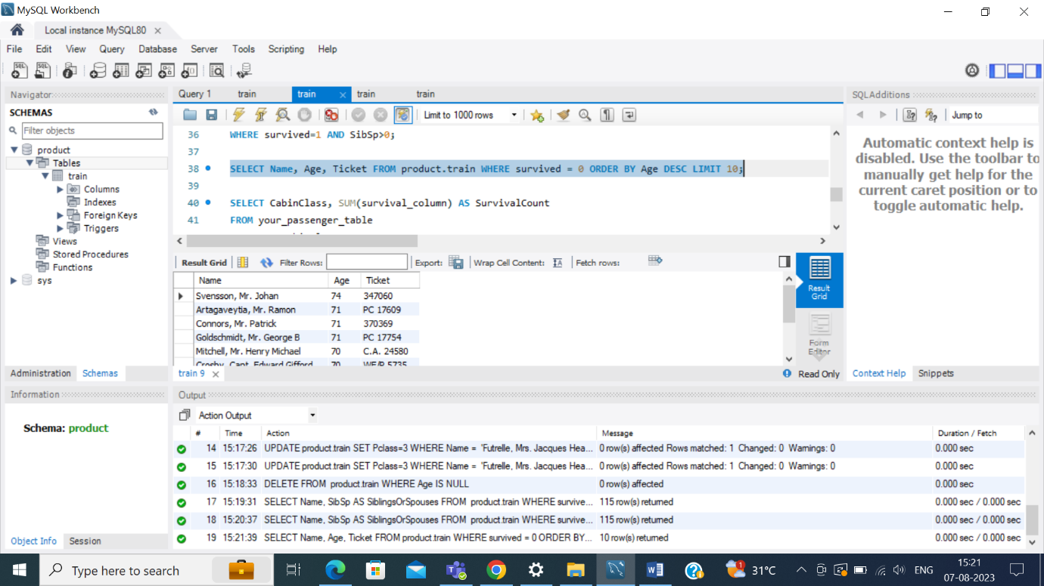

i)Calculate the survival counts for passengers in each cabin class (1st, 2nd, 3rd), and display the results in descending order

SELECT Pclass, Survived, COUNT(*) AS Survival_Count

FROM product.train

GROUP BY Pclass, Survived

ORDER BY Pclass, Survival_Count DESC;

